Tuolumne River Technical Advisory Committee
Don Pedro Project - FERC License 2299

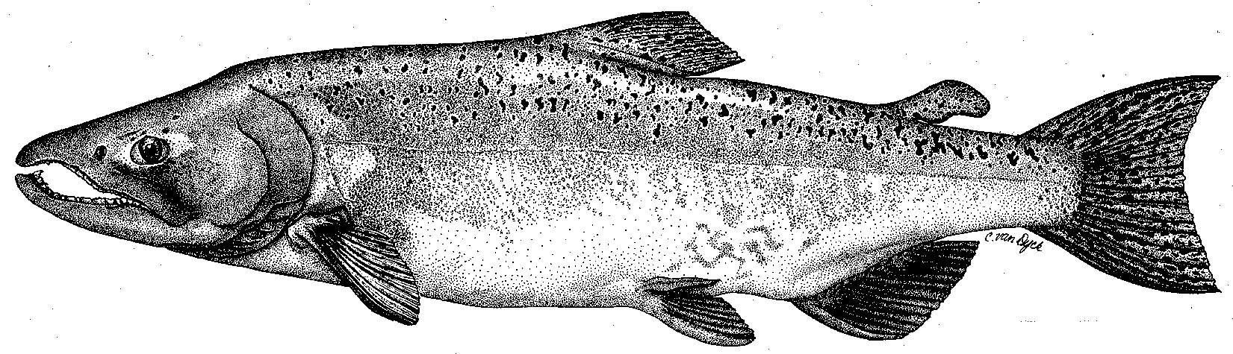

Modesto Irrigation District
Turlock Irrigation District
City & County of San Francisco
California Department of Fish & Game
U. S. Fish & Wildlife Service
333 East Canal Drive
Turlock, CA 95381-0949
Phone: (209) 883-8275
Fax: (209) 656-2180
Email: tjford@tid.org

TECHNICAL ADVISORY COMMITTEE MEETING

December 7, 2005
9:30 AM
Modesto Irrigation District, Room 3A

Draft Meeting Summary

Meeting Objectives:
- Review completed and planned project locations and implementation timing
- Review past project-specific monitoring activities and locations
- Review monitoring included in the PSP [Tasks 3 through 5]
- Discuss and finalize details for project-specific monitoring for TRTAC and FOT projects

Current Tasks
Task 1: Project Management
Task 2: Public Outreach
Task 3: Project Monitoring (7/11, MJR, SRP 9)
Task 4: Fine Sediment Monitoring
Task 5: Coarse Sediment Monitoring
Task 6: River-wide Salmonid Monitoring
Task 7: Aerial Photography and Bathymetry Surveys (Most items already completed under Coarse Sediment Transfusion Project. Items to remain in scope of work are [a] one aerial photo flight following 8,000 cfs threshold, [b] bathymetry from 7/11 bridge to SJR)

Breadth of Scope of Work
- It may be possible to shift unused Task 7 funds to include project monitoring at FOT sites (Bobcat/RM 43, Waterford, and Grayson).
- Current funding and scope for pre- and post-project monitoring at Warner-Deardorff needs to be considered in the study plan. All monitoring must be integrates across projects.
- CDFG/CALFED will likely require coarse sediment augmentation monitoring to be funded under the Coarse Sediment Transfusion Project (assuming the amendment is approved) and will eliminate that task from the PSP monitoring.
- USFWS does not have funds to support a second RST location in winter/spring 2006. Mesick requested that the Districts fund the additional location.

Schedule
- CDFG requires that funds be expended by the end of the third fiscal year after the contract award. Since the fiscal year begins July 1, awarding the contract in February would limit the contract to five months in FY 2005. The TRTAC may want to consider delaying the contract until July so it can cover three full years.

Task 3:
- Contingency re: targeting high flows.
- Integrate riparian surveys at Grayson (and other sites as appropriate with John Stella’s ongoing research).
- Add distance from channel center line as parameter for riparian vegetation recruitment and survival.
- Soils/substrate texture should be included as a monitoring parameter at riparian monitoring sites.
- Accumulation of organic matter should be monitored on constructed floodplains. Organic matter on floodplains may be important for salmonid floodplain rearing. Drift of organic matter from floodplains to the channel should be monitored during the ascending limb of flood events.
- Need adequate control sites for spawning/redd monitoring. All control and monitoring riffles should be identified in the study plan.
- For redd mapping, the following information should be recorded for each redd: flow depth, flow velocity, habitat type (e.g., pool tail, riffle), distance to cover/shade and type of cover. Jen Vick will distribute redd mapping data sheets used at Bobcat/RM 43 to the group for review and comment.
- Stillwater should coordinate with CDFG to determine when to begin redd surveys (i.e., when CDFG begins observing salmon spawning in the monitoring and control reaches).
- Need to incorporate sufficient range of riffle designs to test spawning use by O. mykiss and Chinook vs. design (i.e., long pool tail with steep riffle vs. short pool tail with long riffle).
- Redd mapping/spawning surveys should be extended to included O. mykiss spawning period (especially at Bobcat/RM 43). The group should consider conducting a pilot O. mykiss spawning survey at Bobcat/RM 43 to test survey methods. The pilot might include three surveys conducted over a three-month period.
- Could the project affects groundwater? Is pre-project groundwater data needed?

Task 4:
- Consider adding benthic macroinvertebrate monitoring sites in the primary spawning reach (Task 4d).
- Carl feels that the proposed redd superimposition study does not sufficiently link superimposition to egg/alevin mortality. On the Stanislaus, Carl used artificial redds with baskets/concrete blocks (representing the egg pocket) to test whether superimposition destroyed the egg pocket. He also excavated redds to search for dead alevins. He feels that it is not appropriate to assume that superimposition necessarily destroys the prior redd; egg/alevin mortality must be documented in the field as part of the monitoring. Dennis Hood has also excavated redds on the Stanislaus Rivers to investigate the effects of superimposition. Stillwater should consider excavating at least 2-3 redds at the end of the incubation season.
- Land uses (housing construction and livestock practices) in Dominici and Peaselee creeks have increase sediment supply from these watersheds. This needs to be considered in the analysis of sediment data from these tributaries.

Task 5:
Bulk sampling should be added to the coarse sediment monitoring (in addition to permeability monitoring).
Can photos be used to document the volume of fines in the bed? Stillwater used photos to document fines in the bed several years ago./ Were these analyzed? Are they available to provide baseline data?

Task 6:
- CDFG needs details on the study design and data analysis for proposed angling surveys. Reviewer comments indicated concern regarding the utility of these surveys. A biologist should be present during all angling surveys.
- Noah should check old TRTACMS notes re: proposed O. mykiss surveys for developing the angling study plan.
- Carl Mesick wants to add lipid bioassays/disease evaluations (as done by Scott Foote) for salmonids captured in RST and seine surveys.

Task 7:
How will Task 7 products (and similar products from the Coarse Sediment Transfusion Project) be distributed. Will the TRTAC get CDs/GIS product when products are ready?

Wider PSP Issues:
- Include hypotheses/objectives for each action in study plan.
- Describe how data/results will be used to update/revised conceptual models.
- Need to confirm what amount of budget can be reallocated between tasks without triggering an amendment.
- Consider using river miles to name riffles, coordinate riffle naming between project monitoring surveys and CDFG river-wide surveys.
- Need to identify how TID, Stillwater, and McBain & Trush will handle project management and allocate budget accordingly.
- Budget in Task 2c (Peer reviewed publications) need to be distributed among monitoring contractors.
- The Bobcat Flat Project should be referred to as “Bobcat/RM 43.”
- Is the Tuolumne River Coalition requesting funds through grant programs? (Allison thinks that funds are being sought for a watershed coordinator but not other projects.)
- The current status of the Gasburg Creek amendment and budget need to be confirmed. Relationships between funding in the construction contract and the monitoring PSP need to be clarified.
- The PSP is limited to projects funded by CALFED. Bobcat/RM 43 was funded by CALFED and CDWR. There appears to be sufficient funding from CALFED to include in this site in the scope of the PSP. Allison gave the CALFED contract number to John Batistoni. John will review the contract re: including this site in the PSP.

Contracting Details:
- Finalize project management responsibilities and funding allocation.
- Provide update to John Batistoni re: relationship between Coarse Sediment Transfusion scope and funding and Task 5 of PSP.
- Contact Tim Heyne re: need for 1603 permits for tracer rocks and invertebrate sampling.
- Eliminate Task 3I, incorporate into Task 6.
- Create one separate report task that includes: draft and final monitoring reports, closeout report, and quarterly/annual updates.
- For actions that rely on reaching a flow threshold, identify actions/costs for specific to whether the threshold is met or not.
- A deliverable list and correct budget format must be provided. The budget detail should be provided as soon as possible.

Additional Ideas/Study Questions ”Parking Lot”:
How does flood release timing, magnitude, and duration affect riparian vegetation recruitment?
How do (1) flood timing, magnitude, and duration and (2) floodplain inundation affect salmonid fry and juvenile condition and survival?

