Tuolumne River Technical Advisory Committee
Don Pedro Project - FERC License 2299

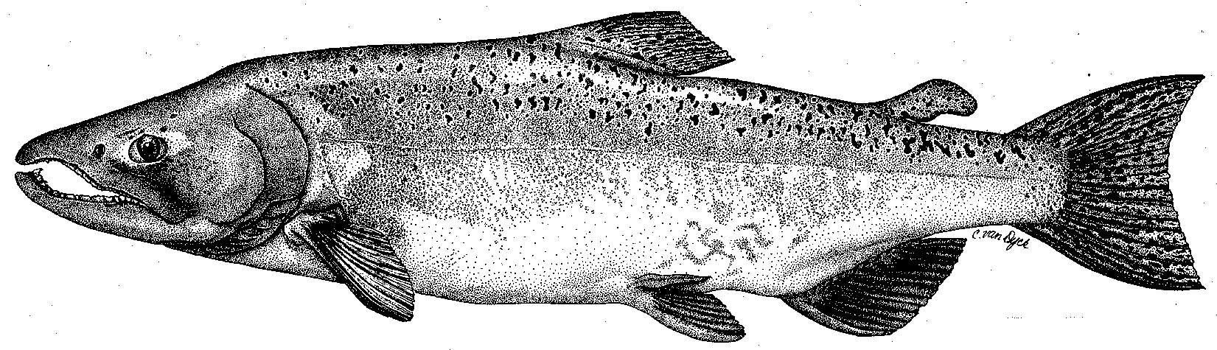

Modesto Irrigation District
Turlock Irrigation District
City & County of San Francisco
California Department of Fish & Game
U. S. Fish & Wildlife Service
333 East Canal Drive
Turlock, CA 95381-0949
Phone: (209) 883-8275
Fax: (209) 656-2180
Email: tjford@tid.org

Monitoring PSP Workgroup Meeting

December 7 and 14, 2005
9:30 AM
Modesto Irrigation District, Room 3A

DRAFT AGENDA

December 7, 2005
Objectives:
- Review completed and planned project locations and implementation timing
- Review past project-specific monitoring activities and locations
- Review monitoring included in the PSP [Tasks 3 through 5]
- Discuss and finalize details for project-specific monitoring for TRTAC and FOT projects

Materials to be provided by Stillwater Sciences and McBain & Trush:
- Map of Tuolumne River projects and monitoring, including locations and dates
- Relevant monitoring reports

Materials that other participants should bring and/or be prepared to discuss:
- Information on completed projects and monitoring
- Specific input on river-wide and project-related monitoring needs
- Complete copies of PSP

Agenda:
9:30-11:30 Review TRTAC projects and completed monitoring (Vick, Hume)
Review FOT projects and completed monitoring (Boucher, Vick)
Review PSP project monitoring tasks and timeline [PSP tasks 3 through 5] (Vick, Hume)

11:30-12:30 Lunch

12:30-3:30 Brainstorm on TRTAC and FOT project-specific monitoring tasks and timelines
3:30-4:30 Summary, consensus, follow-up actions
December 14, 2005
Objectives:
- Review past river-wide monitoring activities and locations
- Review monitoring included in the PSP [Task 6]
- Discuss and finalize details for river-wide monitoring

Materials to be provided by Stillwater Sciences and McBain & Trush:
- Map of Tuolumne River projects and monitoring, including locations and dates
- Relevant monitoring reports

Materials that other participants should bring and/or be prepared to discuss:
- Information on completed projects and monitoring
- Specific input on project-related monitoring needs

Agenda:
9:30-10:30 Review completed river-wide monitoring (Hume, Vick)
Review PSP project monitoring tasks and timeline [PSP task 6] (Vick, Hume)

10:30-11:30 Discuss/review concerns and suggestions for river-wide monitoring

11:30-12:30 Lunch

12:30-4:00 Brainstorm on river-wide monitoring tasks and timelines

4:00-4:30 Summary of consensus, issues, follow-up actions, need for December 21 meeting

