Tuolumne River Technical Advisory Committee
Don Pedro Project - FERC License 2299

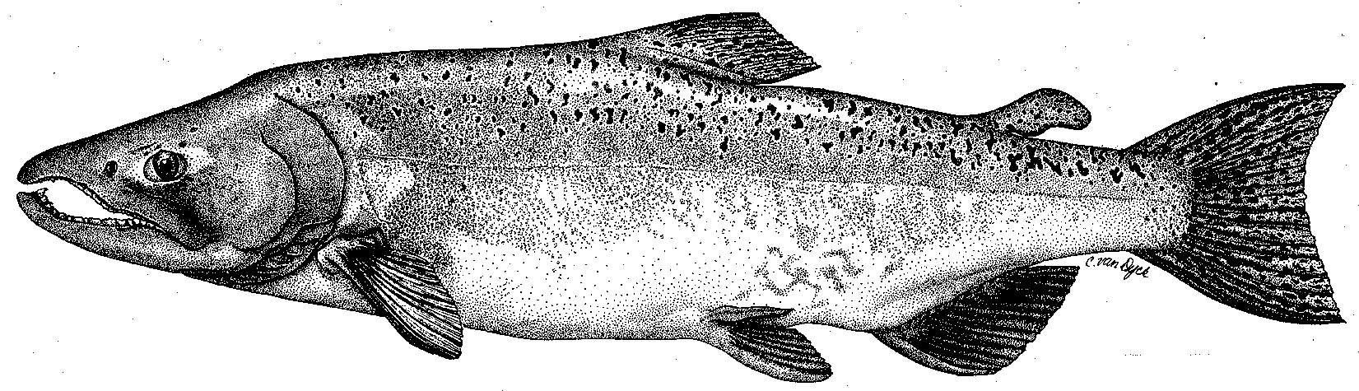

Modesto Irrigation District
Turlock Irrigation District
City & County of San Francisco
California Department of Fish & Game
U. S. Fish & Wildlife Service
333 East Canal Drive
Turlock, CA 95381-0949
Phone: (209) 883-8275
Fax: (209) 656-2180
Email: tjford@tid.org

TECHNICAL ADVISORY COMMITTEE MEETING

14 December 2006
9:30 AM
Turlock Irrigation District, Lunch Room (2nd floor)

Draft Summary

1. Introduction
- Comments on draft agenda and prior meeting summary – none

2. Items since 14Sep meeting

Comments on material list – the listed items were reviewed and a request was made to indicate which items were on TRTAC website

3. Updates

Status of data/reports, including annual report

Ford will later send out draft annual report listing; initial date for pending drafts of component reports was 31Jan; Hume stated there might be an invertebrate update report on 2004-2005 samples; there may also be Grayson River Ranch and Big Bend monitoring reports

- Agency and NGO updates
  - FOT reported both restoration projects have ended for now
  - TID’s EIR for gallery operation is planned for approval next week
  - Ridgeway is retiring from the DFG restoration center at La Grange – vacancy to be filled in Feb.

- Monitoring update – Spawning run; 2007 activities
- DFG reported only 4 tagged carcasses and 2 recoveries in recent river survey; Merced hatchery had only about 380K eggs; DFG scoping of activities under their CALFED grant may be available in Jan; Ford provided handout of weekly live and redd counts on the three rivers.
- Discussion on run estimate methods and weir counts on Stanislaus River – Blakeman noted that the upper part of the Stanislaus cannot be float surveyed; Heyne may provide a review of estimation methods; Ford provided handout on weir counts; constant fractional marking (25%) of hatchery production in Central Valley is planned to start in 2007
- Ford stated that upper screw trap operation will start in January but the specific site near Waterford among both used in 2006 needs to be determined

- Restoration update
  - handout of TRTAC project status from Fryer

4. River operations, flow schedule, and forecasts

Ford provided handout on basin flows starting 01Sep that showed the much higher Stanislaus River flows

5. Additional items
- Ford will look into getting 2005 aerial photos onto website
- DFG may have scoping info in January on their CALFED grant for the tributaries

6. Next meetings and topics:
- TRTAC in 2007 on 08Mar, 14Jun, 13Sep, 13Dec; all start at 9:30 AM at TID

FERC 2299 TRTAC Meeting

14 December 2006

Name Organization

Tim Ford TID/MID
Robert Nees TID
Roger Masuda TID
Walt Ward MID
Ron Yoshiyama CCSF
Dennis Blakeman DFG
Rick Burmester USFWS
Noah Hume Stillwater Sciences
Allison Boucher FOT

