Tuolumne River Technical Advisory Committee
Don Pedro Project - FERC License 2299

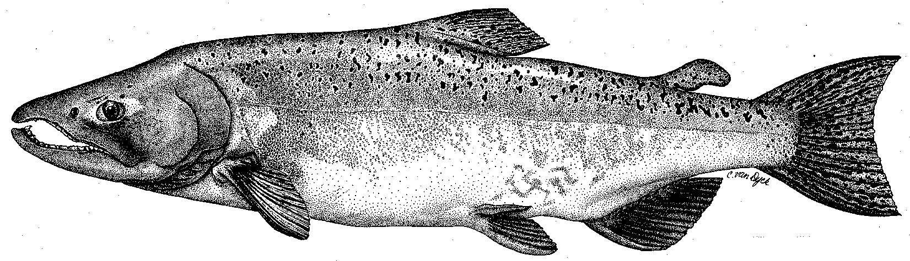

Modesto Irrigation District
Turlock Irrigation District
City & County of San Francisco
California Department of Fish & Game
U. S. Fish & Wildlife Service
333 East Canal Drive
Turlock, CA 95381-0949
Phone: (209) 883-8275
Fax: (209) 656-2180
Email: tjford@tid.org

TECHNICAL ADVISORY COMMITTEE MEETING

14 December 2006
9:30 AM
Turlock Irrigation District, Lunch Room (2nd floor)

DRAFT AGENDA

1. Introduction
- Comments on draft agenda and prior meeting summary

2. Items since 14Sep meeting

Comments on material list
3. Updates

Status of data/reports, incl. annual report
- Agency and NGO updates
- Monitoring update – Spawning run; 2007 activities
- Restoration update

4. River operations, flow schedule, and forecasts
5. Additional items
6. Next meetings and topics:
- TRTAC on 08Mar2007?
- Other 2007 dates

