Tuolumne River Technical Advisory Committee
Don Pedro Project - FERC License 2299

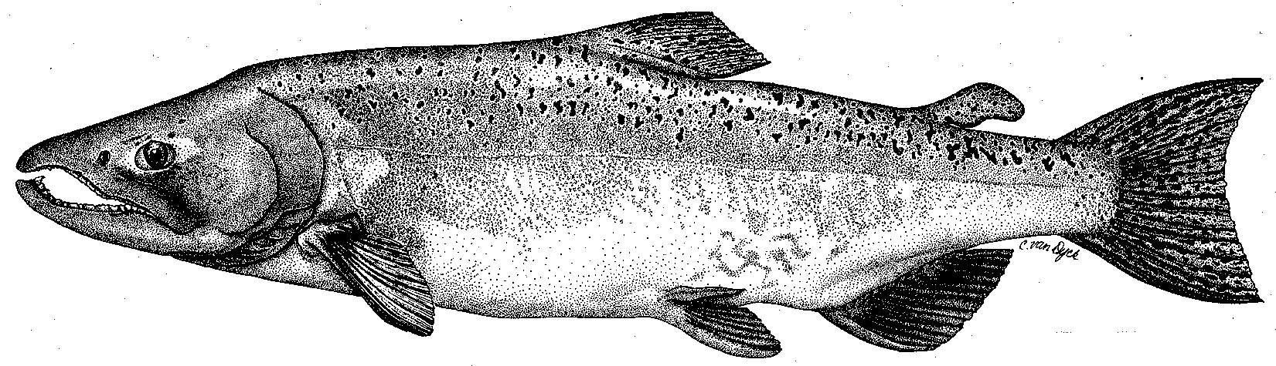

Modesto Irrigation District
Turlock Irrigation District
City & County of San Francisco
California Department of Fish & Game
U. S. Fish & Wildlife Service
333 East Canal Drive
Turlock, CA 95381-0949
Phone: (209) 883-8275
Fax: (209) 656-2180
Email: tjford@tid.org

TECHNICAL ADVISORY COMMITTEE MEETING

08 December 2005
9:30 AM
Turlock Irrigation District, Lunch Room (2nd floor)

Draft Meeting Summary

1. Introduction
- Comments on draft agenda and meeting summary - none
- Items since 04Nov meeting – list of materials was reviewed

2. Items identified at last meeting

Report on 07Dec Monitoring PSP working group meeting – Review of discussion at 07Dec meeting, mostly by Mesick (see separate notes sent out 15Dec); agencies will further confer on monitoring prior to next meeting in 2006; start of work under CALFED PSP is to be determined as either early in 2006 or in Jul2006; Mesick favors using two RST sites (Waterford and Grayson) in 2006 from Jan-Jun; FWS may have some funding available in 2007 for RST monitoring; gravel addition monitoring may be moved to that project from the 2004 PSP; some concern about Warner/Deardorff project monitoring details – will be addressed in 20Dec CALFED Science Panel meeting along with other pending amendments; next workgroup meeting is still set for 14Dec.
- Additional comments on 10-year report – flows are a specific concern of DFG with more needed in some year types.
- Discussion and review on TRTAC restoration projects and coarse sediment management - Handout from Fryer on project status; Reed project is on list, but no funding/work so far; RM 43 has potential for more gravel additions downstream using onsite material; RM 44 is potential site for project work; Ruddy funding of $4M is at risk due to appraisal issues; CDFG plans more gravel additions near La Grange; Gasburg Creek project needs CDFG (landowner) approval; SRP 10 has no construction funding.
- Flow schedule adjustments – Masuda provided a handout on the FSA Section 11 5K acre-feet carryover; Mesick said studies should be decided, then potential flow needs to accomplish those studies; no plan at present to use carryover provision.
3. General Update

Data and report status; items for next annual report – plan to include project monitoring report and possible update on trout data since 2003 filing, CDFG age determination report and genetics report?; otherwise similar to prior reports.
- Agency and NGO updates – McLain reported that (1) Jeff Stuart was in auto accident and will be off until January, (2) Dominici Creek development near La Grange has potential sedimentation issues – NMFS & CDFG involved in settlement, (3) listing of Central Valley steelhead would be based on DPS policy and cover only anadromous fish; DFG will monitor Peaslee Creek feedlot operation for potential river impacts; CDFG reported that silt discharge from 7/11 Gravel, as a result of RWQCB involvement will require mitigation riffles – Action: CDFG to coordinate with TRTAC gravel additions.
- Monitoring update; basin salmon run information - seining will start in mid-Jan; decision pending on RST sampling; marked rocks may be placed; preliminary run estimates are 3,500 Stanislaus, 600 Tuolumne, 2,500 Merced (older stock-recruit model estimated 8,700 for basin); concern about Delta/exports as Sacramento numbers are good; Franz nursery mitigation riffle near Waterford and possibly some new Bobcat Flat riffles had spawning.

River operations and forecasts – potential temporary operation changes with move to Control Area status; continued average rainfall will lead to flood releases in January
4. Additional items – TID drinking water project proceeding with Ceres, Turlock, and Hughson approving studies; still may be 5-6 years away.
5. Next meeting and topics
The meeting will be from 9-1 at TID on 09Feb2006. Topics selected were (1) monitoring – review items identified at 07Dec meeting and issues beyond PSP following 14Dec meeting and (2) gravel placement sites and coordination pursuant to TRTAC and/or CDFG projects. The March meeting could have discussion of potential flow experiments and modeling.

FERC 2299 TRTAC Meeting

08 December 2005

Name Organization

Tim Ford TID/MID
Robert Nees TID
Debbie Liebersbach TID
Wilton Fryer TID
Roger Masuda TID
Patrick Koepele TRT
Tim Heyne DFG
Dennis Blakeman DFG
Carl Mesick FWS-AFRP
Jeff McLain NMFS
Noah Hume Stillwater Sciences
Jen Vick (phone) McBain & Trush

