Tuolumne River Technical Advisory Committee
Don Pedro Project - FERC License 2299

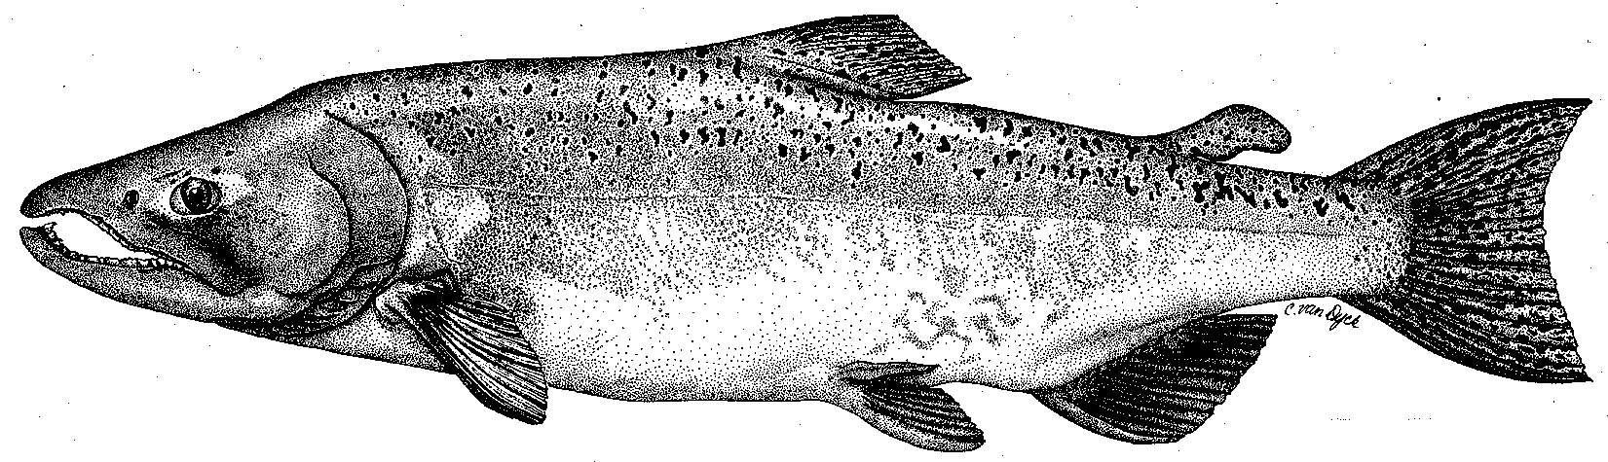

Modesto Irrigation District
Turlock Irrigation District
City & County of San Francisco
California Department of Fish & Game
U. S. Fish & Wildlife Service
333 East Canal Drive
Turlock, CA 95381-0949
Phone: (209) 883-8275
Fax: (209) 656-2180
Email: tjford@tid.org

TECHNICAL ADVISORY COMMITTEE MEETING
17DEC, 2003, 9:30 a.m.
Turlock Irrigation District, Lunch Room (2nd floor)
AGENDA
1. Introduction
- Comments on draft agenda and prior meeting notes
- Correspondence since last meeting
2. ACTION ITEMS:
- Tasks associated with December response to FERC
- 2004 monitoring
3. General FSA Update:

FSA/Order activity, expense tracking, and report status

Review of activities from last meeting

VAMP, Agency, and NGO updates

Monitoring

1. Spawning survey status

2. Sampling proposals (Districts, Mesick, other?)
3. Other monitoring

River operations

F. Restoration
      - Funding, planning and implementation
      - Project monitoring
      - Mesick presentation and Lover’s Leap proposal
      - Other restoration information
4. Additional items
5. Next meeting and topics

