Tuolumne River Technical Advisory Committee
Don Pedro Project - FERC License 2299

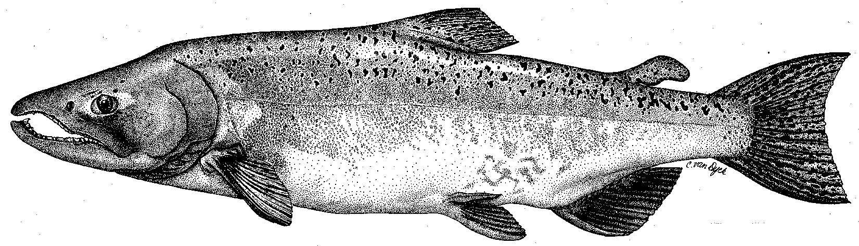

Modesto Irrigation District
Turlock Irrigation District
City & County of San Francisco
California Department of Fish & Game
U. S. Fish & Wildlife Service
333 East Canal Drive
Turlock, CA 95381-0949
Phone: (209) 883-8275
Fax: (209) 656-2180
Email: tjford@tid.org

TECHNICAL ADVISORY COMMITTEE MEETING

04 November 2005
9:30 AM
Turlock Irrigation District, Lunch Room (2nd floor)

DRAFT AGENDA

1. Introduction
- Comments on draft agenda
2. Continue review of monitoring and other evaluations:

CALFED Monitoring Grant:

1. Riverwide

2. Restoration projects

B. Other monitoring or evaluations
3. TRTAC process and communication
4. Flow schedule process
5. Website
6. 08 Dec meeting and topics

