Tuolumne River Technical Advisory Committee

Don Pedro Project – FERC License 2299

Modesto Irrigation District
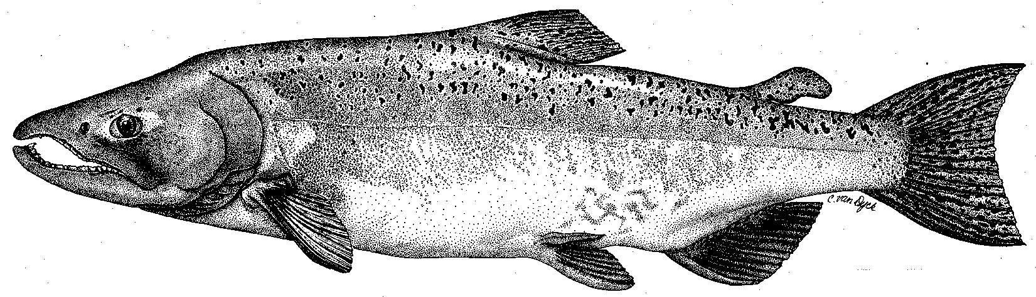

Turlock Irrigation District
City & County of San Francisco
California Department of Fish & Game
U. S. Fish & Wildlife Service
333 East Canal Drive
Turlock, CA 95381-0949
Phone: (209) 883-8275
Fax: (209) 656-2180
Email: tjford@tid.org

10 March 2005
9:30 AM
Turlock Irrigation District, Lunch Room (2nd floor)

Draft Meeting Summary

1. Introduction
A. No changes were made to the agenda
B. Correspondence list was handed out at the meeting and reviewed.

2. General FSA Update:

A. A draft list of items for the 2004 annual report was handed out and reviewed. Blakeman will send out the 2004 spawning report, Ford will send out the 2004 Grayson RST report, and Hume will send out the CWT analysis update.

B. Agency & NGO updates:
Marston (DFG) is being assigned as Water Planning and Project Coordinator and Heyne (DFG) will be the SJR Salmon Project Coordinator and responsible for data needs. Battistoni (DFG) will be the Contract Manager for CALFED project compliance and milestones. Marston is planning a tour for modelers working on the basin temperature model through a TRI-Dam project funded by CALFED.
McLain reported that NMFS is preferred to NOAA Fisheries, steelhead critical habitat has been proposed, and the proposed listing will be in June.
Koepele reported on Big Bend planting – 30 acres N and 30 acres S of 180 total with more planting in April; some inundation is on site.
Boucher reported that RM43 plan is being reviewed and Grayson Ranch sloughs are partly flooded.
Mesick reported that AFRP may have a formal RFP process in April with review by CALFED. The CALFED Ecosystem Restoration Plan (ERP) may have a fall Proposal Solicitation Package (PSP).

C. Monitoring:
DFG had 2004 fall run estimates of 1600 Tuolumne (Schaeffer), 5000 Merced (incl. 1000 at hatchery) and 4000 Stanislaus (about 4400 at weir).
Ford stated the Districts were considering proceeding with RST sampling at Grayson similar to 2004.
DFG indicated they were interested in conducting a large CWT study if flows would be at least 4000 cfs and if funding was provided by AFRP. Total of 800K CWT planned for Merced and VAMP studies.

E. River Operations & Forecasts:
Ford provided handouts of recent basin flows and runoff forecasts – current La Grange flow is about 3000 cfs. There was some interest in having 5500 cfs later in March if feasible.

F. Restoration & Project Updates:
Fryer presented a written summary of the current TRTAC sponsored projects.

- Additional Items:
A tour of the canals near La Grange was set for 20 April, 9 AM at the DFG office.

4. Next meeting and topics:
The next TRTAC meeting will be 22 June 2005 at TID. There may be a subgroup meeting prior to that date.

FERC 2299 TRTAC Meeting

10 March 2005

Name Organization

Tim Ford TID/MID
Debbie Liebersbach TID
Roger Masuda TID
Bill Johnston MID
Allison Boucher FOT
Ron Yoshiyama CCSF
Noah Hume Stillwater Sciences
Dean Marston DFG
Tim Heyne DFG
Dennis Blakeman DFG
John Battistoni DFG
Carl Mesick FWS/AFRP
Jeff McLain NMFS
Patrick Koepele TRT

