Tuolumne River Technical Advisory Committee
Don Pedro Project - FERC License 2299

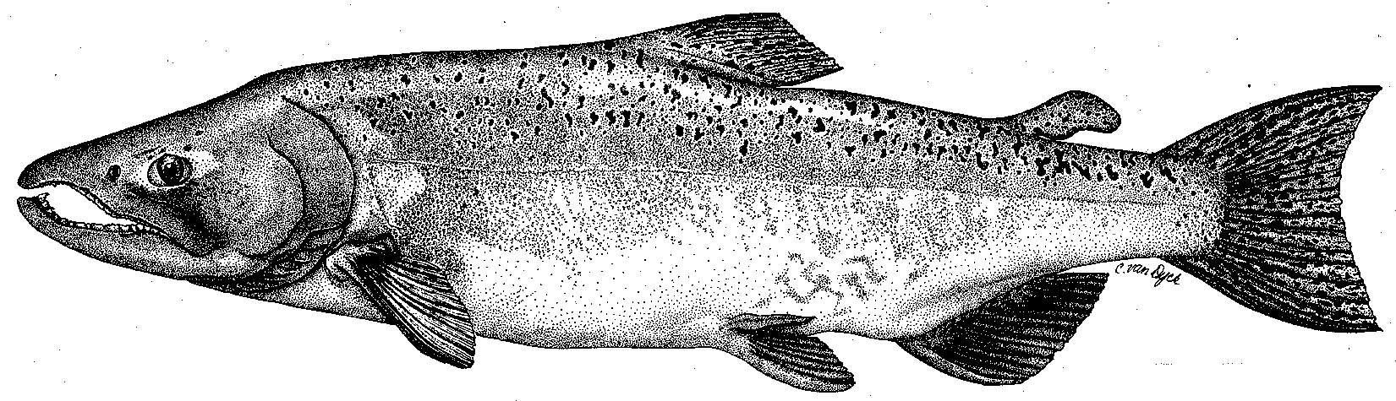

Modesto Irrigation District
Turlock Irrigation District
City & County of San Francisco
California Department of Fish & Game
U. S. Fish & Wildlife Service
333 East Canal Drive
Turlock, CA 95381-0949
Phone: (209) 883-8275
Fax: (209) 656-2180
Email: tjford@tid.org

TECHNICAL ADVISORY COMMITTEE MEETING

13 October 2005
9:30 AM
Turlock Irrigation District, Room 152 (1st floor - WRRA area)

DRAFT AGENDA

1. Introduction
- Comments on draft agenda and meeting summary
2. Review Tuolumne monitoring programs and other evaluations:

Riverwide elements through 2004 by all parties:

1. FERC study program elements

2. Other monitoring or assessments, including TR part of basin or valley-wide elements

Restoration project monitoring through 2004 by all parties (Districts, agencies, NGOs)

Monitoring in 2005 and beyond, including review of various suggested elements

1. Riverwide:

- Districts

- CALFED grant

- Trout-related elements
- Other agencies: DFG, FWS, NMFS

2. Restoration Project:

- Districts

- CALFED grant

- Other agencies/NGO: DFG, FWS, NMFS, FOT, TPT

3. Other monitoring or assessments, including TR part of basin or valley-wide elements
4. Additional items
5. Next meeting and topics

