Tuolumne River Technical Advisory Committee
Don Pedro Project - FERC License 2299

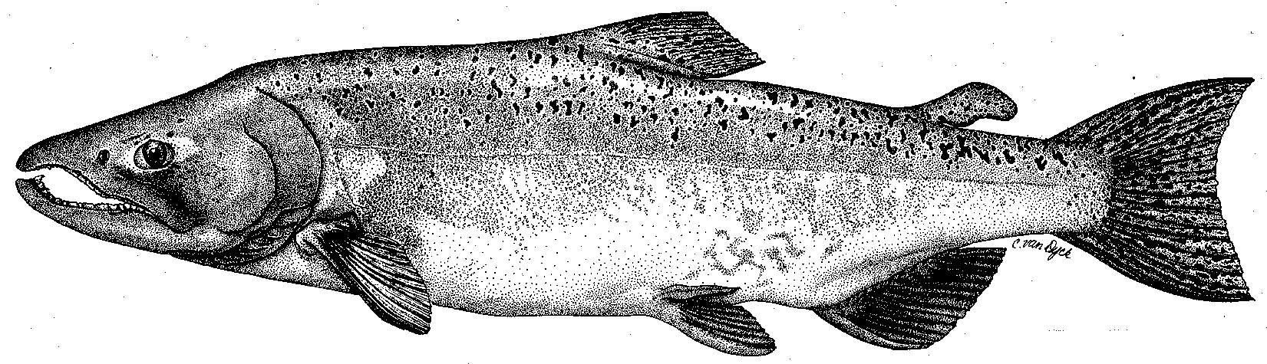

Modesto Irrigation District
Turlock Irrigation District
City & County of San Francisco
California Department of Fish & Game
U. S. Fish & Wildlife Service
333 East Canal Drive
Turlock, CA 95381-0949
Phone: (209) 883-8275
Fax: (209) 656-2180
Email: tjford@tid.org

TECHNICAL ADVISORY COMMITTEE MEETING

13 October 2005
9:30 AM
Turlock Irrigation District, Room 172 (1st floor – GM area)

Draft Meeting Summary

1. Introduction
- Comments on draft agenda and meeting summary – Mesick stated focus should be on #2C; McLain stated discussion of studies was OK, but not flows at this time.
2. Review Tuolumne monitoring programs and other evaluations: Ford went through a Powerpoint presentation/handout on A through C below. Vick provided a 2-page table of CALFED grants tasks and other monitoring

Riverwide elements through 2004 by all parties:

1. FERC study program elements

2. Other monitoring or assessments, including TR part of basin or valley-wide elements: Suggestions were to list Water Quality (WQ) programs such as SWAMP and NAWQA and to depict all items here by year

Restoration project monitoring through 2004 by all parties (Districts, agencies, NGOs)

Monitoring in 2005 and beyond, including review of various suggested elements

1. Riverwide: added seine and snorkel survey sites to be determined

- Districts

- CALFED grant

- Trout-related elements: lavage could add info. on diet during angling survey
- Other agencies: DFG, FWS, NMFS

2. Restoration Project: Need to generally better inform group of changes/decisions affecting projects or their monitoring

- Districts

- CALFED grant

- Other agencies/NGO: DFG, FWS, NMFS, FOT, TPT: Add riparian recruitment study and Grayson Ranch monitoring

3. Other monitoring or assessments, including TR part of basin or valley-wide elements: Need to develop proposals for future opportunities; most listed are trout-related suggestions from prior meetings; need to follow-up on trout habitat suitability and temperature criteria review; pebble counts will be done for gravel addition sites; Mesick suggested examining food/floodplain dynamics from high flows as part of inquiry on how river functions and fish respond; priorities to be determined by TRTAC; discussion of potential reasons for salmon numbers, fish response from projects, issues of gravel additions (size, source, composition, etc.); need to review existing data on local rivers and then identify new evaluations
4. Additional items: HEC cross-section handout (17Sep2005 flight) for topographic river model; DFG basin thermograph location handout for basin model development
5. Next meeting and topics: 04Nov (see Sep summary); Mesick to develop list of questions/objectives and propose how to evaluate; others may pose similar list/issues for TRTAC evaluation

FERC 2299 TRTAC Meeting

13 October 2005

Name Organization

Tim Ford TID/MID
Robert Nees TID
Debbie Liebersbach TID
Roger Masuda TID
Allison Boucher FOT
Patrick Koepele TRT
Ron Yoshiyama CCSF
Noah Hume Stillwater Sciences
Tim Heyne DFG
Dennis Blakeman DFG
Carl Mesick FWS-AFRP
Jen Vick McBain&Trush
Steve Walser CRRF
Jeff McLain (part only, by phone) NMFS

