Tuolumne River Technical Advisory Committee
Don Pedro Project - FERC License 2299

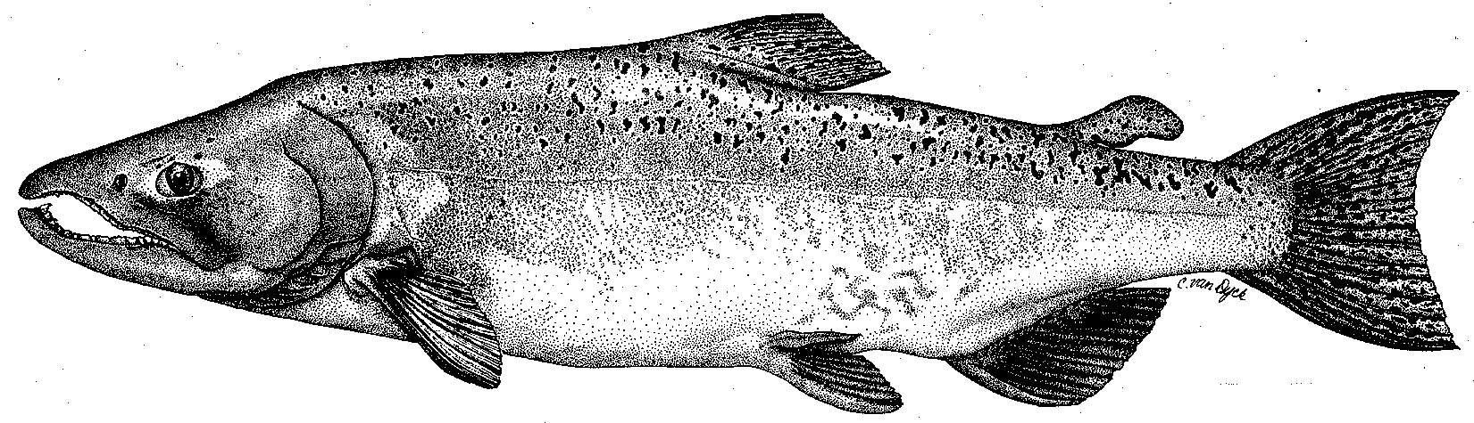

Modesto Irrigation District
Turlock Irrigation District
City & County of San Francisco
California Department of Fish & Game
U. S. Fish & Wildlife Service
333 East Canal Drive
Turlock, CA 95381-0949
Phone: (209) 883-8275
Fax: (209) 656-2180
Email: tjford@tid.org

TECHNICAL ADVISORY COMMITTEE MEETING

21 September 2005
9:30 AM
Turlock Irrigation District, Lunch Room (2nd floor)

Draft Meeting Summary

1. Introduction
- Comments on draft agenda - none
- Correspondence since last meeting – very limited (no handout)
2. Discussion on 2005 10-year report:
Ford: Handout of 20 Sep FERC notice of additional comment periods through 22 Nov and 22 Dec
Various issues and viewpoints were identified or discussed:
- How will monitoring and future analysis issues be decided?
- CALFED monitoring grant has been approved – grant agreement to be developed should have TRTAC approval and input;
- should revisit various priority lists and monitoring suggestions – need for clear plan
- support for more screw trap sampling - perhaps changes needed to other studies
- issues of TRTAC operations and conflict resolution should be resolved
- riverkeeper (independent – work with landowners)
- need for facilitator
- better DFG warden enforcement
- request that action items be identified in advance and e-mails have one subject
- modeling issues
- need to address adding NMFS more formally into process, including flow scheduling
- need for website to facilitate TRTAC operation/function and information access
Action: It was decided to have additional meetings scheduled to further discuss these and other issues raised through the FERC comment process. Issues identified for future meeting topics include: monitoring/studies, TRTAC process (communication, data exchange, participation), flow scheduling and coordination with VAMP, etc., modeling, restoration projects, and other topics to be addressed as they are identified
Action: Mesick and Ford were assigned to review various monitoring elements for the next meeting
3. General Update:

Data and report status – Heyne identified their Sportfish Report format has changed; Basin WT model should be in draft form by Mar 2006 from AD Consultants – Heyne reported that WT data is being collected from reservoirs and rivers and river cross sections are being used. Ford stated that a “project monitoring update report” through 2004 will be available – plan is to get any remaining data/reports caught up this year;
Action: Districts will follow-up with DFG on Sportfish Reports and other data needs
Action: FOT and TRT project seine data to be provided for inclusion with other seining data

Agency and NGO updates:

CCSF: Ramirez moving to them from CALFED

CRRF: Walser reported large trout this summer down to near Waterford; possible spring run salmon seen; dead carp observed in lower Tuolumne and San Joaquin Rivers

TPT: Koepele has two Nov canoe trips planned and planting days at Big Bend in Oct and Dec

FOT: report on Bobcat Flat project status

Monitoring update – Districts: snorkeling underway this week – many trout observed at upper sites; recent thermograph download – data should be available soon; invertebrate samples were again collected in summer – many fines at site below Bobcat Flat; Districts will provide assistance to DFG carcass survey again this year

River operations and forecasts – DFG (Marston) has been coordinating fall schedules in the basin that are still being finalized; Tuolumne pulse will be about 500 cfs for two weeks; no excess flows will be released in near-term on Tuolumne; flow schedule process to be discussed further

Restoration – Status update handout from Fryer; inchannel restoration work for the RM 43 project at Bobcat Flat is completed; Boucher reported that 16K cubic yards of gravel were added at 3 sites and 35K yards were stockpiled – a 5000 cfs floodplain channel was constructed; Heyne stated that DFG intends to do more gravel additions near La Grange in 2006 with 4-pumps funding; Ruddy project still is in jeopardy due to appraisal process – could affect Warner-Deardorff project as well; SRP10 land purchase may need to proceed soon;

Action: overall restoration project status and selection will be reviewed
4. Additional items –
5. Next meetings and topics as noted – Meetings were set as follows (at TID at 9:30 AM): 13 Oct (monitoring, incl. review of past monitoring, agency monitoring, project monitoring, trout monitoring, CALFED grant, proposals in comments to FERC, special studies, etc.); 04 Nov (TRTAC process and communication; flow schedule process; website); 08 Dec (TBD). Quarterly meeting dates were selected for 2006 on 2nd Thursdays: 09 Mar, 08 Jun, 14 Sep, and 14 Dec.

FERC 2299 TRTAC Meeting

21 September 2005

Name Organization

Tim Ford TID/MID
Robert Nees TID
Debbie Liebersbach TID
Roger Masuda TID
Allison Boucher FOT
Patrick Koepele TRT
Ron Yoshiyama CCSF
Noah Hume Stillwater Sciences
Tim Heyne DFG
Carl Mesick FWS-AFRP
Jeff McLain NMFS
Steve Walser CRRF

