Tuolumne River Technical Advisory Committee
Don Pedro Project - FERC License 2299

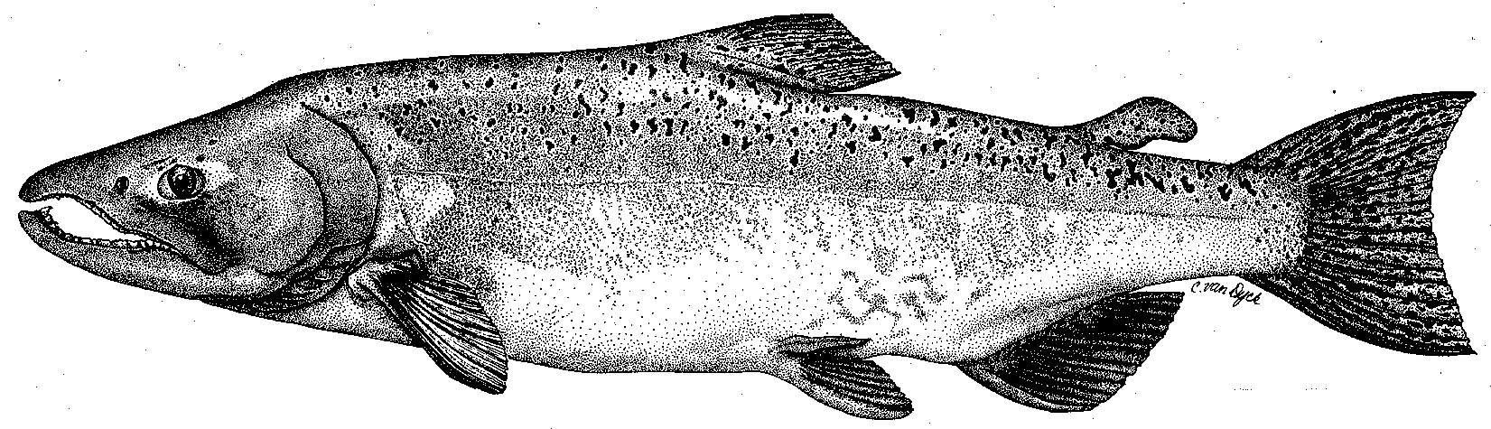

Modesto Irrigation District
Turlock Irrigation District
City & County of San Francisco
California Department of Fish & Game
U. S. Fish & Wildlife Service
333 East Canal Drive
Turlock, CA 95381-0949
Phone: (209) 883-8275
Fax: (209) 656-2180
Email: tjford@tid.org

TECHNICAL ADVISORY COMMITTEE MEETING

21 September 2005
9:30 AM
Turlock Irrigation District, Lunch Room (2nd floor)

DRAFT AGENDA

1. Introduction
- Comments on draft agenda
- Correspondence since last meeting
2. Discussion on 2005 10-year report
3. General Update:

Data and report status

Agency and NGO updates

Monitoring update

River operations and forecasts

F. Restoration
4. Additional items
5. Next meeting and topics

